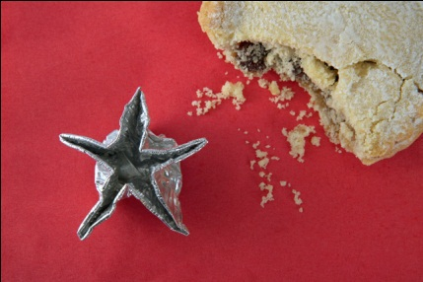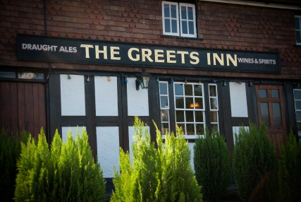

***CHRISTMAS CELEBRATIONS AT THE GREETS***

**Available 22nd November to 23rd December 2024**

**Tomato and red pepper soup** with garlic and herb crouton **(ve)**

**Red onion marmalade and goats cheese tart** with mixed leaf salad and balsamic glaze **(v)**

**Greets own chicken liver, garlic and mushroom pate,** pickle selection and ciabatta toast

**Deep fried camembert**, spicy tomato chutney **(v)**

**Classic prawn cocktail** with marie-rose sauce

**Avocado, walnut and mixed leaf salad** with French dressing **(ve)**

C:\Users\Greets Inn\AppData\Local\Microsoft\Windows\Temporary Internet Files\Content.IE5\D0A35B5K\MP900448447[1].jpgC:\Users\Greets Inn\AppData\Local\Microsoft\Windows\Temporary Internet Files\Content.IE5\D0A35B5K\MP900448447[1].jpgC:\Users\Greets Inn\AppData\Local\Microsoft\Windows\Temporary Internet Files\Content.IE5\D0A35B5K\MP900448447[1].jpg

**Roast golden turkey breast**, sage and onion stuffing, pigs in blankets, roast potatoes, and seasonal vegetables

**Pan fried sea bass fillet,** crushed new potatoes, baby spinach and prawn butter

**Venison and winter vegetable casserole** with herby dumplings

**Shepherd’s pie topped with spring onion mash** with braised red cabbage

**Tomato, garlic and olive linguine** with garlic bread **(ve) add chicken breast**

**Wild mushroom and leek risotto**, rocket leaves and chilli oil **(ve)**

C:\Users\Greets Inn\AppData\Local\Microsoft\Windows\Temporary Internet Files\Content.IE5\D0A35B5K\MP900448447[1].jpgC:\Users\Greets Inn\AppData\Local\Microsoft\Windows\Temporary Internet Files\Content.IE5\D0A35B5K\MP900448447[1].jpgC:\Users\Greets Inn\AppData\Local\Microsoft\Windows\Temporary Internet Files\Content.IE5\D0A35B5K\MP900448447[1].jpg

**Warm Triple chocolate brownie** with honeycomb ice cream **(vegan /GF option available)**

**Classic crème brulee** with shortbread biscuit

**Warm homemade mince pie** with fresh cream

**Zesty lemon cheesecake** and pouring cream

**Sussex Charmer and Sussex Blue Cloud cheeses** served with savoury biscuits and homemade blueberry chutney

**Selection of ice creams and sorbets**

C:\Users\Greets Inn\AppData\Local\Microsoft\Windows\Temporary Internet Files\Content.IE5\D0A35B5K\MP900448447[1].jpgC:\Users\Greets Inn\AppData\Local\Microsoft\Windows\Temporary Internet Files\Content.IE5\D0A35B5K\MP900448447[1].jpgC:\Users\Greets Inn\AppData\Local\Microsoft\Windows\Temporary Internet Files\Content.IE5\D0A35B5K\MP900448447[1].jpg

**Two course Lunch or Dinner £31.50**

**Three course Lunch or Dinner £37.50**

**SPECIAL EARLY DINING OFFER**

**DINE BETWEEN 22 November–28 November**

**Two course £28.50 Three course £34.50**

A non-refundable deposit of £10.00 per person payable by cash or bank transfer (please request bank details) is required to confirm a booking.

Full payment is required 10 days in advance, along with a food preorder

Call on **01403 265047 or email** to make a booking

The Greets Inn 47 Friday Street Warnham West Sussex RH12 3QY [info@thegreetsinn.co.uk](mailto:info@thegreetsinn.co.uk) [www.thegreetsinn.co.uk](http://www.thegreetsinn.co.uk)

**Food allergies and intolerances**

**Please ask a member of or team about ingredients in your meal when making your order. Thank you. Genetically modified vegetable oil used**